A Flexible Email Client App

|  |  |
| --- | --- |
| **Team Members** | **NM Id** |
| R.Chandhar | 01DA9CD11A2317A8CE7411956DCCB0A0 |
| E.Dhasaravi | 06AE072CC7147E180DD4732944F8CE56 |
| J.Madhan | E3011AE5BF0354EAE7145CEFA0688F93 |
| R.Vignesh | 7F7D045064E713383D04BF4169782CAC |

Required Initial Steps:

**Step 1.:Download Android Studio: - Visit the official Android Studio download page:**

[https://developer.android.com/studio](https://developer.android.com/studio).

* **Review and accept the terms and conditions if prompted.**
* **The download will begin automatically.**

**Step 2.:Install Android Studio:**

**For Windows:**

 Run the installer: Double-click the downloaded `.exe` file.

 Follow the installation wizard:

* + **Choose installation options (use default settings unless you have specific preferences).** o **Android Studio requires a minimum of 4 GB of RAM**

(recommended 8 GB), and a screen resolution of at least 1280x800.

 Install Android SDK: The installer will automatically install the Android SDK, Android Emulator, and other necessary tools.

 Complete installation: Click `Finish` once the process is complete.

 3. Follow the setup wizard: Android Studio will guide you through the rest of the installation.

# Step3: First Launch and Setup:

 Choose UI Theme**: Select between `Light` or `Dark` theme.

 Install SDK Components**: Android Studio will download necessary SDK

components (such as the latest Android platform and tools). This might take some time, depending on your internet speed.

# Step 4: Configure Android Studio:

 -Install additional SDK packages: You might need to install certain packages depending on your Android development needs (e.g., specific Android API versions or system images for the emulator).

 Set up the Android Emulator: If you plan to use the Android Emulator for testing, you can set it up through the AVD (Android Virtual Device) Manager.

# Step5: Verify Installation:

 Go to `File` → `New` → `New Project`.

 Choose a template (e.g., `Empty Activity`).

 Configure the project (e.g., name, package name).

 Click `Finish`.

# Step6: Install Android Device/SDK Drivers (If needed):

 You have enabled USB debugging on the device (`Settings` → `About phone` → Tap `Build number` 7 times to unlock developer options → `Developer options` → Enable `USB debugging`).

 You may need to install specific drivers for your device (especially on Windows).

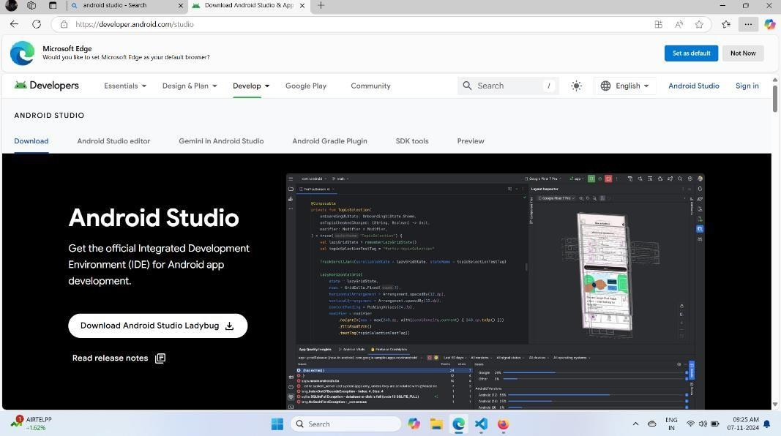**Screen Shorts:**